To the Presidents of all EBL NBOs
Cc EBL Executive Committee Members
EBL T.D. Committee Members
EBL Tournaments Directors
NBO International TDs

Monday 21st February 2022

EBL Max Bavin Tournament Directors Course
15th to 18th September 2022
Novotel Airport Hotel
Warsaw, Poland

Dear Presidents, dear Friends,

We are pleased to inform you that the 12th EBL Main Tournament Directors Course in memory of Max Bavin will be held from 15th to 18th September 2020 at the Novotel Airport Hotel, Warsaw, Poland.

Schedule
The complete schedule and work programme will be published later. Please note that the Course will start on Thursday 15th September at 16:00 and will end on Sunday 18th
September at 12:00.

Participation
The TD Course is reserved for:
1. EBL TDs and the NBO International TDs on the EBL TD Register.
2. TDs who have achieved A+ or A at an EBL Workshop
3. A limited number of TDs who have attended previous courses or workshops.
Preference will be given to TDs from NBOs not represented in the above 2 categories.

Objectives
The primary objectives of the Course are:
a) to support the NBOs in their activity through updating the knowledge of their leading Tournament Directors,
b) to offer the NBO Tournament Directors the opportunity to achieve the title of NBO International Tournament Director and to be appointed in the EBL Official TDs Register,
c) to offer to the NBO International TDs the opportunity to achieve the title of EBL TD and to be appointed in the EBL Official TDs Register,
d) to offer to the EBL TDs, already appointed in the EBL Official TDs Register, the opportunity to keep or improve their category.

Participation fee (including Course and accommodation for 3 nights with full board)
Single Room = € 450
Double Room= € 400 per person
Non-participant in Double Room (full board) = €200

Registration

Attached is the Registration form. Further details regarding the course will be sent to NBOs, NBO TD Contacts and TDs later.

Sincerely yours,
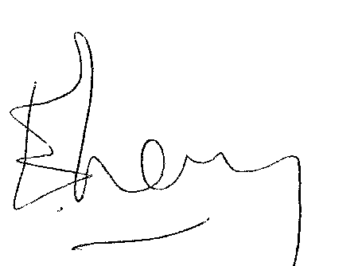

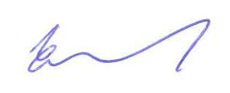

Eitan Levy Jan Kamras
EBL TD Committee Chairman EBL President

