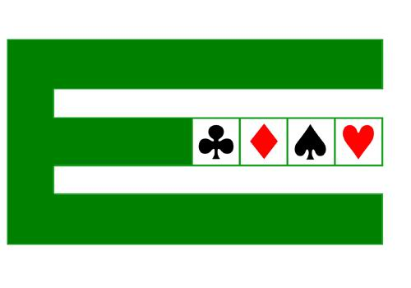
EUROPEAN BRIDGE LEAGUE

General Assembly 2018
Ostend, 9th June

LIST OF CANDIDATES TO
THE EXECUTIVE COMMITTEE
LEGISLATURE 2018 - 2022

PRESIDENCY
Aubry | Yves | France
De Pauw | Marc | Belgium
Kamras | Jan | Sweden

EXECUTIVE COMMITTEE
Atay | Sevinç | Turkey
Audouard | Olivier | France
Belčák | Peter | Slovakia
Carić | Jurica | Croatia
Chalupec | Igor | Poland
Conforti | Francesco | Italy
Counil | Jean-Louis | France
Cronier | Philippe | France
De Pauw | Marc | Belgium
Gerontopoulos | Panos | Greece
Harris | David | England
Harsanyi | Josef | Germany
Kamras | Jan | Sweden
Kielbasinski | Radoslaw | Poland
Laurant | Eric | The Netherlands
Levy | Eitan | Israel
Nicolás-Correa | Elisa | Spain
Ofir | Gilad | Israel
Oikonomopoulos | George | Greece
Ólafsson | Jafet | Iceland
Opsal | Kari-Anne | Norway
Porteous | Paul | Ireland

