Yves Aubry
President

To the Presidents of the EBL NBOs

Wednesday 8th October 2014

EBL TOURNAMENT DIRECTORS WORKSHOP
ATHENS, GREECE

Dear President,

Starting 2011, the EBL Executive Committee decided to develop its Tournament Directors Training Programme by starting a series of EBL TD Workshops.

These workshops are designed for TDs who are not on the Official TD Register of the EBL. The aim is to support local TD training in the NBOs by improving the knowledge and synchronizing the work and methodology of TDs. Special care will be taken to improve the TD’s work in the small federations. The language of instruction is English, and a working knowledge of English is required.

The Main EBL TD Courses (held every two or three years) are restricted to TDs who appear on the official EBL Register. However, participants who are successful in the Workshops will also be invited to the Main Course where they will have the opportunity of achieving the level of EBL Director.

The next course will be held in Athens, Greece from 2 – 5 February 2017 as detailed below:

- Hotel President Hotel, 43 Kifissias Avenue, Athens, Greece
- Participation fee €350 per person including 3 nights hotel accommodation,
full board, TD course and all programmes.
- Application EBL secretariat – by the NBO (see application form attached)

Sincerely yours,


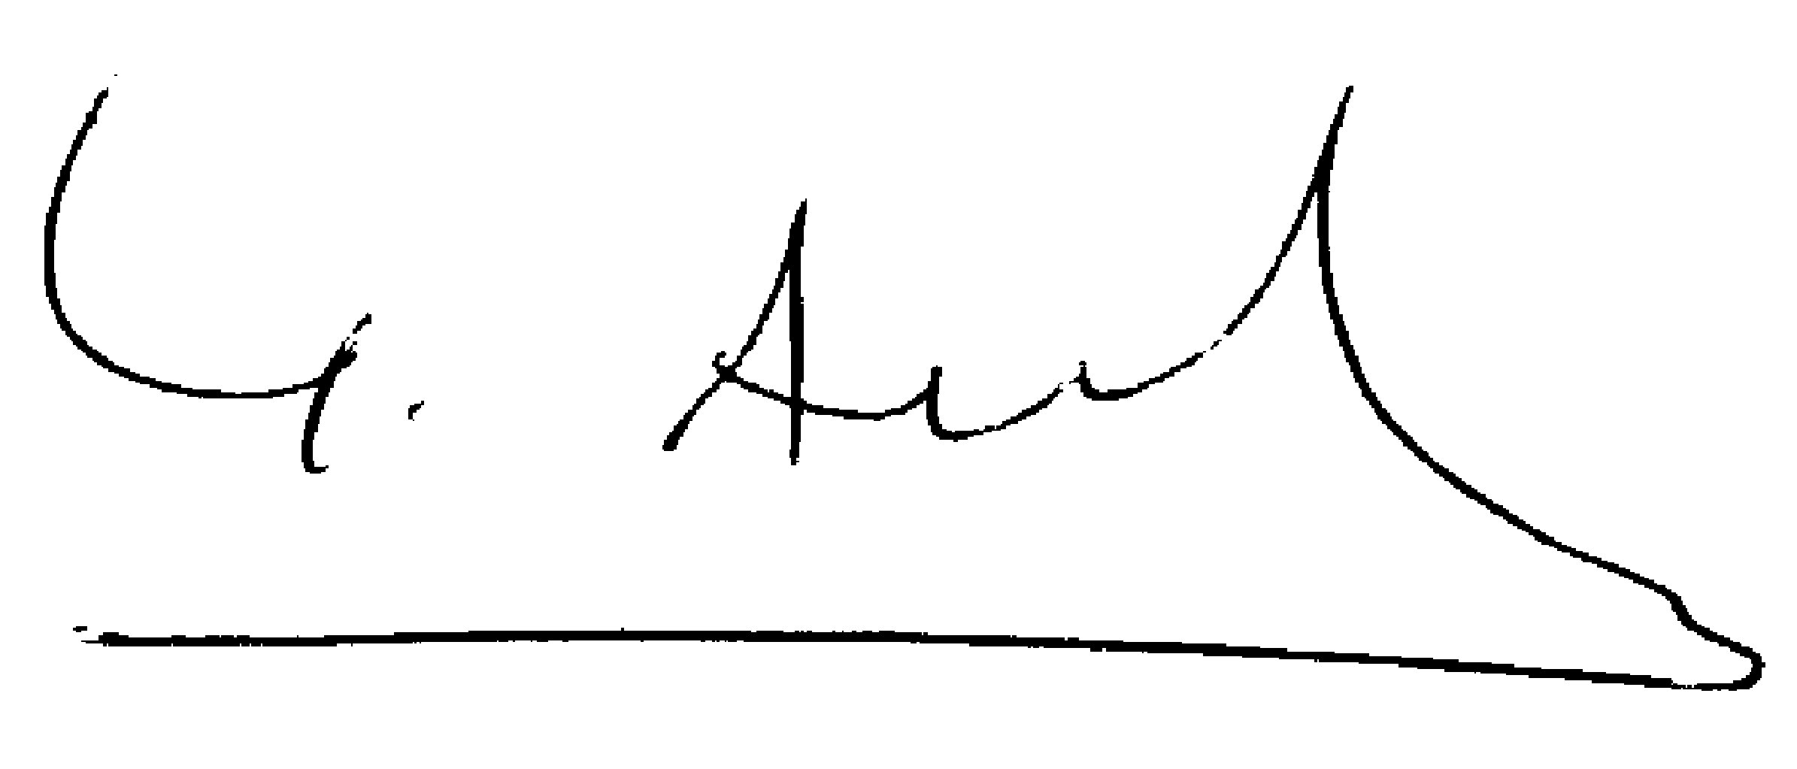

Eitan Levy Yves Aubry
EBL TDs Committee Chairman EBL President

Attached : - Application form

